[#](http://www.napier.ac.uk/)

**Title:** Coursework Part 1

**Matriculation Number:** 40512375

**Module Title:** Database Systems

**Module Number:** SET11101

**Name of Module Leader:** Pete Barclay

**Date of Submission:** 11/11/2021

Contents

Introduction 3

Original schema 3

Modified schema 4

Report query 5

Test plan 5

References 5

# Introduction

In this coursework, starting we have to select an already existing database design, modify it according to the coursework’s needs and create an annotated ER diagram using the UML notation. Following we have to create a query that will require data from 3 tables and includes an aggregation. Last a test plan for our report will be created and we will explain which data are needed and how we ensure that the result from our query will be the correct one.

# Original schema

The original database design is a Blood Banks database designed using the Crow’s feet diagram and represents who donates the blood and all the necessary or not details for him, where is the blood saved after the donation and the information for that place and the staff that works in the place the donations was made and the blood was saved.

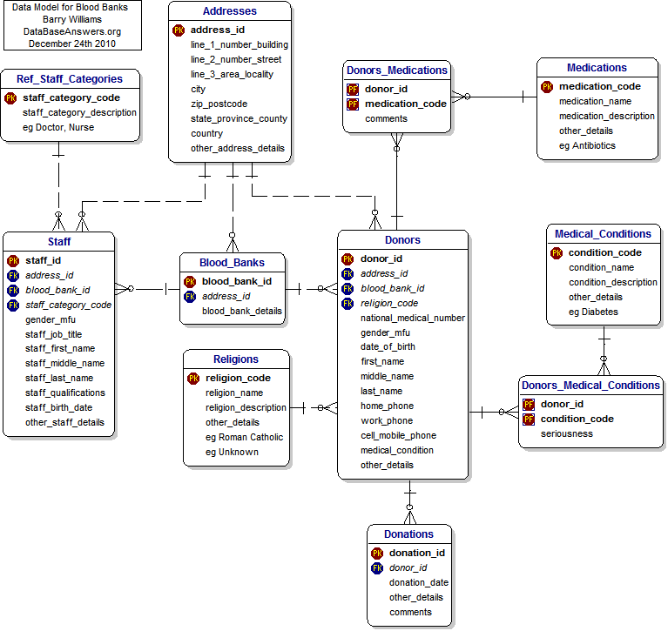(www.databaseanswers.org, n.d.)

# Modified schema

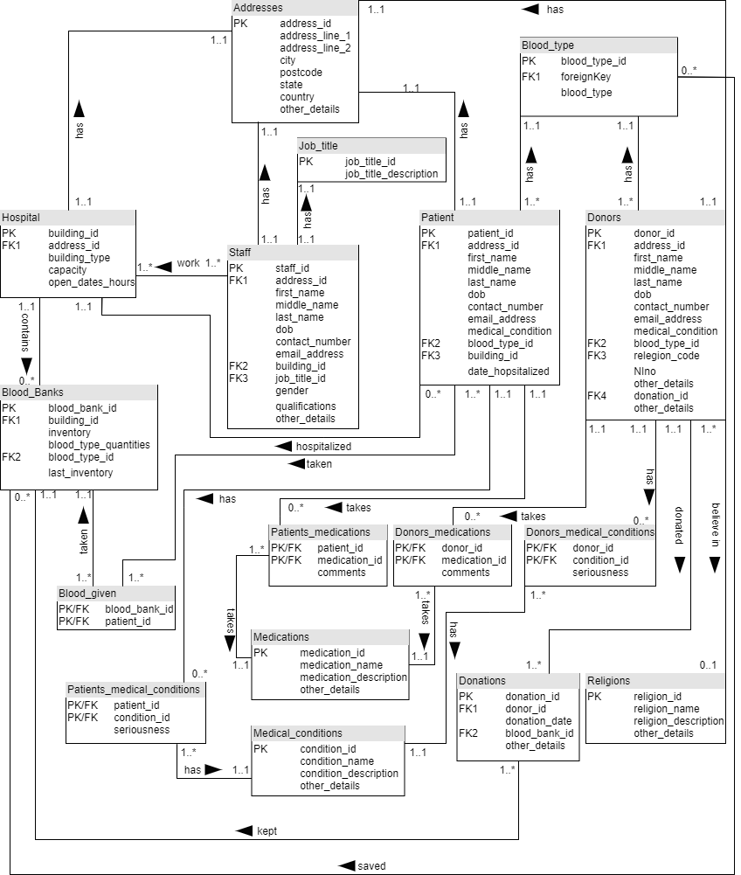

The modifications to the original database were made to transform it from a simple blood bank database to a national blood bank database. The new database shows the needs of blood in a country, who are the donators and all the information needed, where is the blood saved after the donation, which patients need blood, and from which blood bank will be taken. Also which staff works in each hospital, which has a blood bank, how much blood each blood bank has.

# Report query

Show how many patients in each hospital, that has a blood bank, have blood type 0- and group them by most to least.

# Test plan

When the database is built in MariaDB we can run the above query and test it if the database works as is supposed to. The data that will be required will be from entity patient the PK patient_id and the FK2 blood type_id and the FK3 building_id. From entity blood type will be used the attribute blood_type in order specify the 0- blood_type_id. From the Blood Banks will be used the FK1 building_id because we need only the hospitals which have a blood bank. So as a result we should have the number of patients hospitalized in hospitals where the patient FK3 building_id is the same with blood bank FK1 building id and the blood_type_id has the attribute blood type =0-.

The result should look like this:

|  |  |
| --- | --- |
| Hospital Type | How many patients |
| Lothian Primary Care Nhs Trust | 15 |
| Royal Edinburgh Hospital | 13 |
| Lynebank Hospital | 5 |
| Royal Scottish National Hospital | 3 |
| St Vincent's Hospital | 0 |

# References

www.databaseanswers.org. (n.d.). Blood Banks Data Model. [online] Available at: [Blood Banks Data Model (databaseanswers.org)](http://www.databaseanswers.org/data_models/blood_banks/index.htm) [Accessed 3 Nov. 2021].